TECHNICAL SPECIFICATION

**CANBIO V 800 SE**

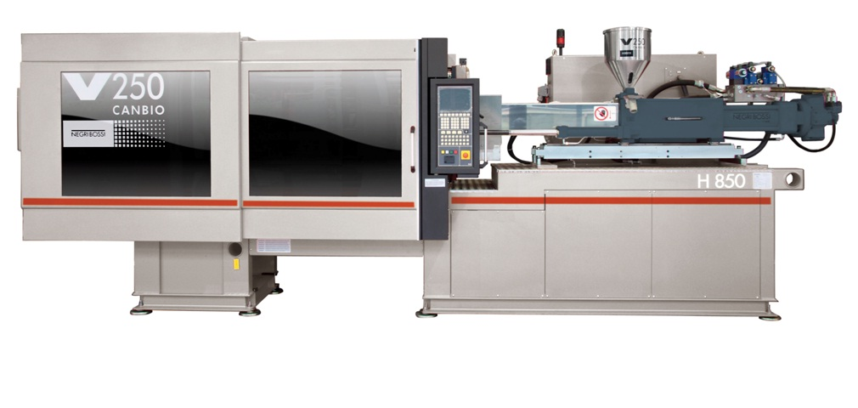

*(indicative picture)*

MACHINE NEGRI BOSSI SERIES CANBIO

MODEL V 800 SE

EUROMAP 8000 H - 4250

SCREW DIAM. 100 MM

OVERALL DIMENSION AND LIFTING DRAWING





***STANDARD EQUIPMENT***

## MOLDS

1. Five point double toggle clamp.
2. Hardended posts.
3. Mobile plate sliding on posts through self-lubricating bushes.
4. Mobile plate sustained by pads.
5. Powered mold thickness control.
6. Automatic central lubrication system by means of electric pump.
7. Three-stage mold closing speed profile.
8. Three-stage mold opening speed profile.
9. Mobile plate pre-feed.
10. Mold closing and opening stages governed through closed loop with proportional control valve.
11. Digital reading of mobile plate position given on visual display unit.
12. Digital reading of clamping force given on visual display unit.
13. Two-stage ejection speed profile.
14. Ejection force control.
15. Digital reading of ejector position given on visual display unit.
16. Ejector proportional speed control, with overlapped movement at opening (starting from V160-820).
17. Repeated ejection with stroke and speed control.
18. Safe guarding provided for ejector return stroke.

## INJECTION UNIT

1. Injection unit with hydraulic cylinder coaxial to screw.
2. Injection unit sliding through self-lubricating bushes.
3. Universal screw suitable for all types of thermoplastic materials.
4. Bimetalic plasticizing cylinder.
5. Nitrited screw.
6. Injection unit driven by two cylinders to assure perfect nozzle centering with mold.
7. Operating modes selected from amongst:
8. Nozzle always near mold;
9. Injection unit idle motion before or after plasticizing stage.
10. Plasticizng cylinder warmed up by ceramic heating elements.
11. Alarm threshold for set temperature range.
12. Injection stage governed with set pressure and speed profiles.
13. Switching to post-pressure selected from amongst:
14. Screw position
15. Hydraulic pressure
16. Time
17. Digital reading of screw position given on visual display unit.
18. Settable screw rotation speed profile.
19. Delayable screw rotation.
20. Settable back-pressure profile.
21. Digital reading of back-pressure given on visual display unit.
22. Piping before and after dosing.
23. Intrusion.
24. STAINLESS steel hopper.

## HYDRAULIC SYSTEM

1. The hydraulic group uses digital variable displacement pumps with integrated electronic control of pressure and speed allowing higher energy savings. The electric motor, asynchronous three-phase with standard (not forced) ventilation, is driven by an electrical power drive that allows, in close loop, the variation of electric motor RPM and the pump displacement. The prefect regulation of motor RPM and pump displacement assures the highest transmission performance with a considerable energy saving. Moreover the machine turns out to be more quite.  
   The quantity of oil required is also reduced, which in turn allows the necessary energy for cooling to be reduced to a minimum.  
   For these reasons we can say that CANBIO VSE is a very ecological machine.  
   A cutting-edge electric-hydraulic system provides rational, efficient use of energy  even when the IMM is being used at maximum performance levels.  
   Digital networking of servo-pumps and proportional distributors ensures outstanding communication efficiency with the IMM control and also allows components to be monitored and set-up directly from the control.
2. Digital reading of hydraulic circuit pressure given on visual display unit.
3. Monitoring of :

- Oil level.

- Oil temperature.

- Oil filter clogging.

1. Oil temperature control system.
2. Cooling water shut off valve.
3. Oil preheating program.
4. Oil filter in pump delivery and/or return circuit.
5. Heat exchanger to cool down oil.
6. Oil gauge.

## ELECTRICAL SYSTEM

1. Remote starter with overload cutout .
2. Main switch to prevent electrical cabinet from being opened when press is energized.
3. Fuses and static relays that control plasticizing cylinder heating.
4. Fan for air circulation in electrical cabinet.
5. LED indicators on solenoid valves.

## COOLING CIRCUIT

1. Flow meter with independent channels used to read water temperature and delivery rate and make adjustments. One channel is used for the plasticizing cylinder near the hopper whereas the remaining channels are used to cool down the mold.

## BASE

1. Piece discharge outlet accessible on three sides.
2. Sound-proof motor-pump assembly housing.
3. Holes for leveling in anti-vibration plates.
4. Lubricating oil recovery trough.

### SAFETY DEVICES

1. Constructed in compliance to essential requirements of Machinery Directive 2006/42/CE and subsequent ammendments.
2. All models CE certified by an European certification organization.
3. Devices comply to European Standard EN 201.
4. Rear mold protection with double interlocking device and pump drive motor shutdown.
5. Correct operation of hydraulic and electric safety devices monitored.
6. Electric safety device for nozzle protection.

## ELECTRONIC CONTROL

1. Personal computer integrated in machine complete with two “CANBUS” outputs.
2. Color monitor.
3. Keyboard to retrieve setup pages for work units.
4. Configured keys in work unit.
5. Areas provided on display screen where main press parameters can be consulted.
6. Data input lock out key.
7. Hour counter.
8. Perpetual clock.
9. Page with press technical specifications.
10. Cycle times with sequence alarm page.
11. Three speed steps to close mold can be set in relation to speed and position.
12. Two pressures during mold closing with pressure limited to protect mold, position in which operation takes place can be set.
13. Mold pre-feed.
14. Position of molds in relation to position of mold holding plate.
15. Closure feedback signal.
16. Three speed steps to open mold can be set in relation to speed and position.
17. Closed loop control of position to open mold.
18. Mold cooling pause.
19. Screw and mold installation page.
20. Lubrication cycles.
21. Clamping force reading.
22. Number of settable ejection cycles.
23. Two ejection speed steps.
24. Partial return stroke during repeated ejection.
25. Pressure to move ejector out and back in can be adjusted.
26. Data of ejector, blowers and cylinders.
27. Closed loop speed control for injection stage.
28. Closed loop pressure control for holding stage.
29. Up to ten injection speed steps can be set.
30. Switching to post-pressure according to time, hydraulic pressure or screw position.
31. Up to ten post-pressure steps can be set.
32. Screw decompression before and after dispensing.
33. Screw rotation settable in five steps.
34. Closed loop screw speed control.
35. Screw back-pressure can be set in five steps.
36. Closed loop back-pressure control.
37. Self-adjusting dispensing system.
38. Speed and pressure for programmable injection system approach and idle motion.
39. Program to automatically calculate dispensing value according to material and weight.
40. Parallel interface for printer.
41. No. 2 USB ports
42. High resolution graphs and quality control pages.
43. Monitored energy consumption.
44. Memory for more than 500 molds.
45. Two languages involved(Bulgarian and Russian)



MODEL

**CANBIO V800-4250 SE**

Std. Screw ø100mm

***OPTIONS***

Anti-vibration Pads

2 hydraulic cores

2 hot runner controls

1 pneumatic valve

4 plugs

Hopper loader

**SMART ENERGY VERSION**

The hydraulic group uses digital variable displacement pumps with integrated electronic control of pressure and speed allowing higher energy savings. The electric motor, asynchronous three-phase with standard (not forced) ventilation, is driven by an electrical power drive that allows, in close loop, the variation of electric motor RPM and the pump displacement. The prefect regulation of motor RPM and pump displacement assures the highest transmission performance with a considerable energy saving. Moreover the machine turns out to be more quite. The quantity of oil required is also reduced, which in turn allows the necessary energy for cooling to be reduced to a minimum. For these reasons we can say that CANBIO SE is a very ecological machine. A cutting-edge electric-hydraulic system provides rational, efficient use of energy even when the IMM is being used at maximum performance levels. Digital networking of servo-pumps and proportional distributors ensures outstanding communication efficiency with the IMM control and also allows components to be monitored and set-up directly from the control.